**Physics 20 - Lesson 16**

**Friction – Answer Key**

/ 60

1)

B. Decelerating because of kinetic friction.

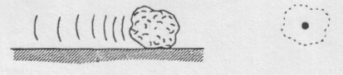

A. Sliding at constant speed without friction.

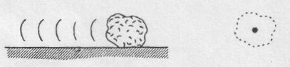

FN

Fg

FN

Fg

Ff

/4











2)



/7

3)





/4











4)

/8













5)



/6

6) a)



/6





b)



7)











/8





Find *FN*





200N











8)

/10

Find *Ff*



Find *Fnet* and *a*



9)













/7

